
KONERU LAKSHMAIAH EDUCATION FOUNDATION
(Deemed to be University estd, u/s, 3 of the UGC Act, 1956) Green Fields, Guntur District, A.P., India – 522502
Department of Electronics and Communication Engineering
(DST - FIST Sponsored Department)
Course Code: 24SDEC01R Program: B.Tech - ECE
Course Title: ELECTRONIC SYSTEM DESIGN Academic Year: 2025-26- II/IV-II Sem

SKILL EXPERIMENTS RESULTS
STUDENT NAME: Y.Harshavardhan STUDENT ID: 2400040454
EXP. No: 2 DATE: 18/07/2025

TITLE OF THE EXPERIMENT: : Designing a Temperature-Controlled Fan Circuit

AIM: To design and implement a PCB for controlling a fan based on temperature
using Easy EDA.

COMPONENTS REQUIRED:
EasyEDA software
A computer with an internet connection
A schematic of the temperature-controlled fan

CIRCUIT DIAGRAM:
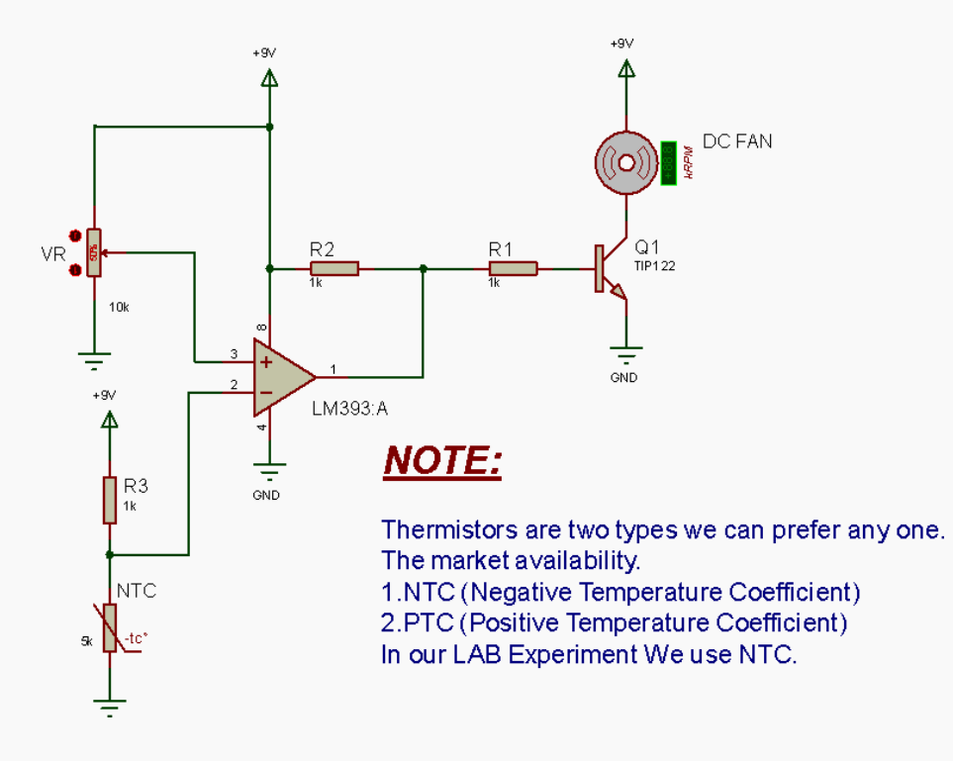
SCHEMATIC:
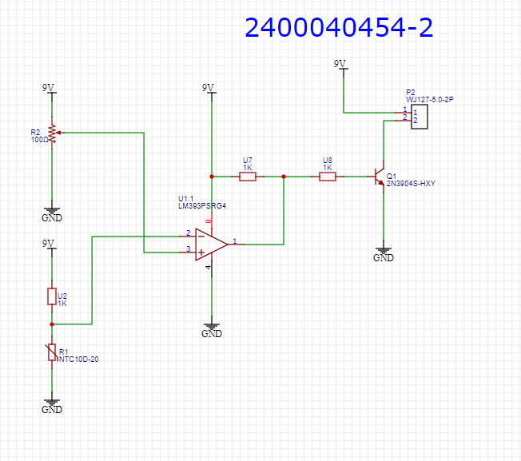

PCB LAYOUT:
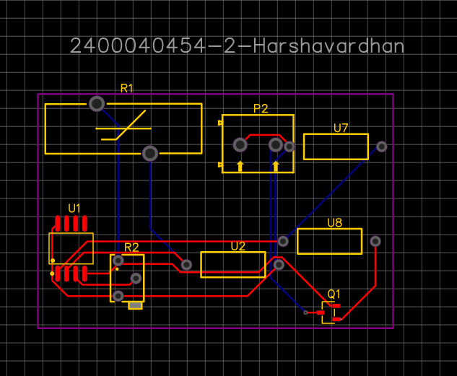

2D VIEW:
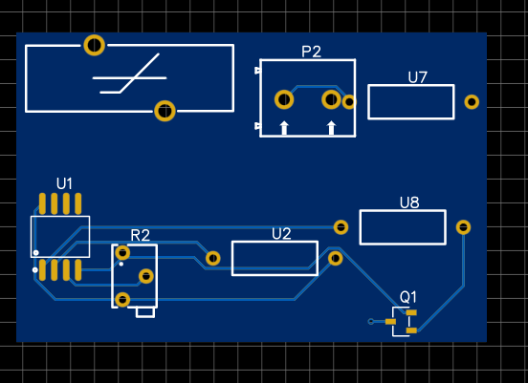

3D VIEW:
